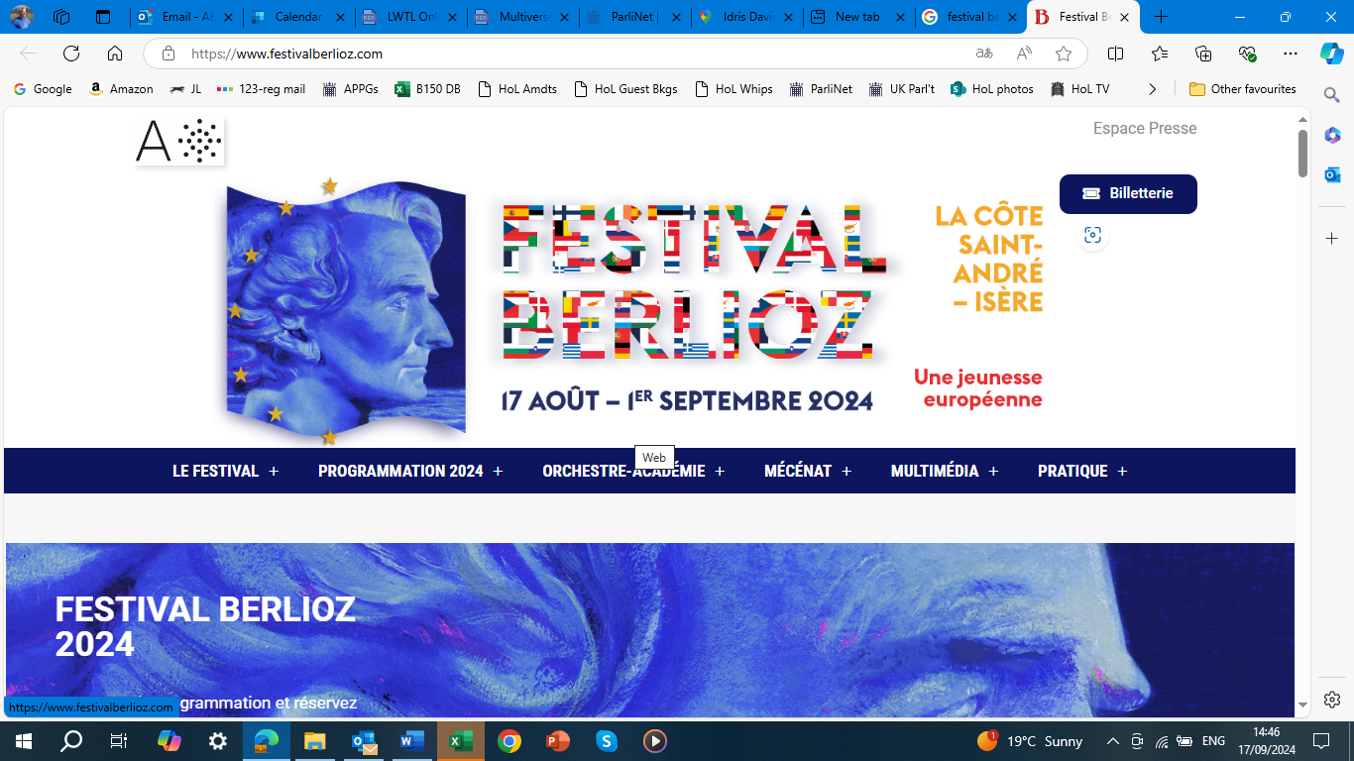

The theme of this year’s Festival Berlioz was “Une jeunesse européenne”: like so many pithy French phrases (“A travers chants” and “Les grotesques de la musique” come to mind!), seemingly simple, but hard to translate precisely; “European Youth” is the best I can do, but doesn’t have quite the same ring. This theme was reflected in the involvement of a variety of young performers and orchestras and an exhibition at the Musée Berlioz of musical toys; it also sought to foster a spirit of youthful optimism and delight in music, even among us older Europeans.

In terms of Berlioz’s own compositions, the fare on offer was perhaps a little thinner than usual, particularly in comparison with the previous year’s triumphant performances of both parts of *Les Troyens*. Having said that, the two-week programme included four of Berlioz’s overtures, as well as the *Symphonie Fantastique*, *Les Nuits d’été*, *Harold en Italie*, *La Mort de Cléopâtre*, *L’Enfance du Christ*, the song *La Belle Voyageuse* from *Irlande* and orchestral excerpts from *Roméo et Juliette*, so one could hardly claim that Berlioz was not strongly represented.

We arrived in La Côte-Saint-André about half-way through the Festival, on Wednesday 28 August, and were puzzled to find the town sign upside down – apparently as a protest by farming unions. That evening we attended the second concert given by the Orchestre Français des Jeunes, the French Youth Orchestra, although we were unable to stay for the second half. The orchestra numbered about 90 players, including 60 strings and nine percussionists, and very impressive they were in the two first-half pieces: Berlioz’s *Benvenuto Cellini* overture and the Tchaikovsky second Piano Concerto, with Elizabeth Leonskaja as the soloist, led by their chief conductor, the Estonian Kristiina Poska.

Both works were thrillingly played. The overture was idiomatic and full of youthful fire and exhilaration. The orchestral ensemble was truly spectacular, and might have overpowered the piano soloist, had Poska not reined back the volume where necessary to let her be heard. Leonskaja herself was phenomenal, not least in a remarkable extended cadenza in the first movement; the transitions between orchestra and soloist were brilliantly managed.

I have left my highest praise until last, namely for the conductor, who made a powerful impression in both works; with the baton in her left hand (I don’t recall ever seeing this before), and with notable economy of gesture with the right, she conveyed an extraordinary sense of control and authority, often by simply pointing a finger. The way the orchestra and Leonskaja struck sparks off each other under Poska’s impressive leadership was memorable. I hope to hear more of her.

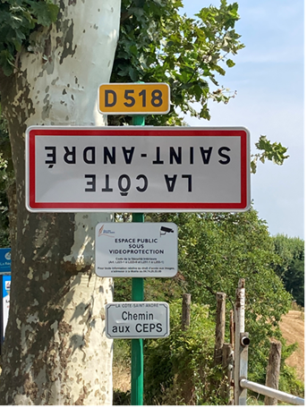

The town sign: turned upside down by farming union protestors

We gave the following day’s evening concert a miss; but in the afternoon I went to a lecture at the Musée Berlioz by the Berlioz scholar Cécile Reynaud, Vice-President of Research at the Ecole Pratique des Hautes Etudes, University of Paris and formerly of the Bibliothèque Nationale de France, on her new book (with co-author Gisèle Séginger) *L’Épopée au Siècle de Berlioz* (“The Epic in the Age of Berlioz”). Much of this was beyond my French comprehension, but bought the book anyway, for its excellent illustrations as well as the interest of its contents.

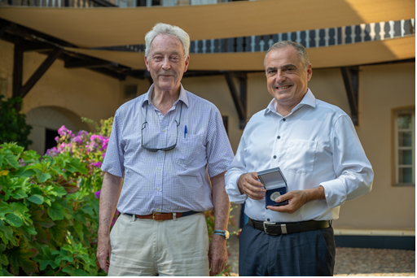

Bruno Messina with the Berlioz Society medal presented by Alastair Aberdare

After the lecture, I had the pleasure of presenting the Berlioz Society Medal to Bruno Messina, the Director of the Festival, who has done so much to put Berlioz on the map, both in France and beyond, including for those members of the Berlioz Society who have had the opportunity to visit the Festival. We had hoped to be able to present the medal during Bruno’s planned visit to London in 2023, but this had to be postponed; he assured me, though, that he still intends to visit us, hopefully during 2025.

While at the Musée I visited the exhibition accompanying this year’s Festival, entitled *Musique de chambre … d’enfant!* (“Chamber Music … for Children!”) – consisting of musical toys from primitive rattles and drums to today’s singing dolls and sophisticated technology-based children’s music devices. While this was of rather more specialist than Berliozian interest, it did include items such as the guitar which Berlioz himself is believed to have played in his youth.

The following morning we were again at the Musée, not to attend the Annual General Meeting of the ANHB (Association National Hector Berlioz), which would certainly have been beyond my French language capability, but to present another Berlioz Society Medal to Antoine Troncy, the Director of the Musée, who is recovering from illness and had been unable to attend the previous day.

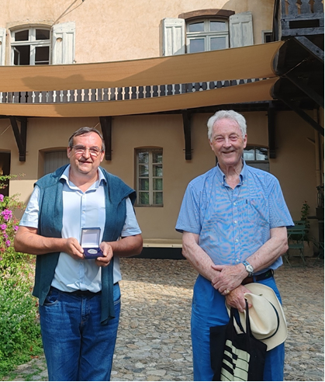

Antoine Troncy with his Berlioz Society Medal

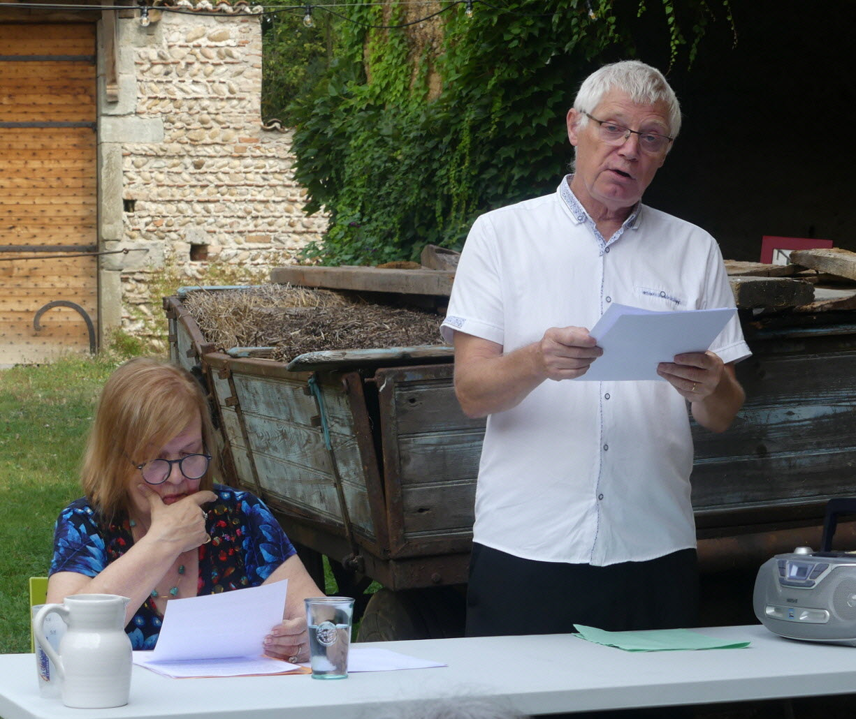

Pascale Beyls talks about his book “Marie Pleyel” (formerly Camille Moke)

After their AGM, the members of the ANHB went for lunch at the [Ferme Berlioz](https://www.lafermedeberlioz.org/), the Berlioz family farm at the edge of La Côte, which over recent years has been impressively restored by Karine and Hervé Pilaud. They were no doubt dismayed to find me turning up yet again, like a bad penny, for a lecture by Pascale Beyls based on his own new book on “Marie Pleyel, pianiste virtuose” – the former Camille Moke, to whom Berlioz was briefly engaged in 1830. As with Pascale’s other books about Berlioz’s friends and relations, this is a meticulous summary of everything he has been able to find out about Camille, running to 533 pages, including her surviving letters. Apart from enjoying Pascale’s talk, I learnt two French expressions roughly similar to turning up “like a bad penny”: “comme un cheveu sur la soupe” (like a hair in one’s soup) and “comme une brebis galeuse” (like a mangy sheep); take your pick!

The concert that evening (Friday 30 August) featured Paul McCreesh conducting the NFM Wrocław (formerly Breslau) Philharmonic orchestra and choir in Berlioz’s *L’Enfance du Christ*. I have rated McCreesh highly as a Berlioz conductor ever since his magnificent recording of the *Requiem*, among the best there is; he does wonderful work with children through his *Gabrieli Roar* programme, and one of my dreams is to hear him conducting the *Te Deum*, including the optional choir of 600 children added by Berlioz following his experience of hearing 6,500 children singing in a Charity Children’s concert at St Paul’s Cathedral in London in 1851.

After a wonderfully hushed start, with tenor Laurence Kilsby an outstanding Narrator singing in very idiomatic French, the remainder of the first part was a little slower and less dramatic than it can be. Neal Davies didn’t quite “nail” the role of Herod: he had the vocal resources, but didn’t convey the full force of Herod’s fury and frustration. The Centurion and Polydorus were unnamed members of the chorus; one of them (I’m not sure which) had better French. The Soothsayers gave the performance a lift, and indeed the chorus was excellent throughout; the smallish orchestra too was fine, apart from a few minor fluffs and uncertainties of ensemble. Anna Stephany was a first-rate Mary, not quite matched by Benjamin Appl as Joseph.

Any doubts about the performance were swept aside by Parts 2 and 3. The Shepherds’ Chorus and subsequent narration in Part 2 never fail; and Part 3 turned out best of all, especially with the appearance of Ashley Riches’s splendid Householder, and an equally splendid performance of the Trio for flutes and harp. The ending was simply magical, as the Narrator and Chorus together sang the final “O mon âme” (Oh my soul), musing softly on the mystery of the infant Christ’s survival,. The performance justly earned an ovation for McCreesh and his forces.

The following evening’s concert was entitled “Ravel and Berlioz”, with the National Orchestra of Lyon conducted by Daniele Rustioni. The first half consisted of orchestral excerpts from Berlioz’s *Roméo et Juliette*: Romeo alone, followed by the Capulets’ Ball; the Love Scene, and the Queen Mab scherzo. Daniele Rustioni belongs to the school of conducting by making wild gestures and jumping up and down; the orchestra played perfectly well, but it wasn’t clear how much attention they were paying to him. During the Love Scene my attention was distracted firstly by Rustioni’s wild gyrations and secondly by regular and prolonged nose-blowing by a child sitting behind me. The performance missed any sense of the emotions conjured up by Berlioz (and of course Shakespeare): what we heard, albeit well enough played, might have been better described simply as “Three orchestral pieces”, which slightly misses the point of the work.

The second half of the concert consisted of Ravel’s *Daphnis et Chloe*, Suites 1 and 2. The orchestra, further enlarged, seemed happier in these, and Rustioni slightly less wild. They were performed with considerable energy, precision (for the most part) and enthusiasm, if with little depth of feeling.

The final concert of the Festival, on Sunday 1 September, featured a full-strength London Symphony Orchestra (with over 100 players for the final piece) and their relatively new Chief Conductor, Sir Antonio Pappano. This was one of those concerts where I knew from the opening bars that it would blow me away. Berlioz’s overture *Le Carnaval Romain* was performed with fantastic precision and exuberance. Every contrast, of dynamics, speed and emotion, was brilliantly spotlit: . It had everything that the previous night’s *Roméo et Juliette* excerpts lacked.

This was followed by Richard Strauss’s *Burleske in D minor* for piano and orchestra: a strange piece, but never less than intriguing. It included a major role for the timpanist, who seized on it with glee, and was rewarded by being picked out by Pappano at the end. The piano part was impressively played by Bertrand Chamayou, who evidently relished playing with an orchestra on such top form. After the *Burleske*, he played Ravel’s *Pavane pour une infante défunte –* evidently something of a party piece for him – as an apt solo encore.

The concert ended with Holst’s *The Planets*: a thrilling, overpowering, magnificent performance. A relentlessly thunderous *Mars* set the tone for a performance which showcased a great orchestra unleashing the full range of its talents in every department. *Nimrod* from Elgar’s *Enigma* Variations was played as a thoroughly appropriate encore. At the end Pappano brought each section in turn to its feet, and the sell-out audience duly responded with a standing ovation. We can only hope that the palpable triumph of this concert will persuade both the Festival and the LSO that they should return as soon as possible to perform some more substantial Berlioz at a future Festival.

So despite what had initially seemed a rather limited programme of Berlioz works, Libby and I found this year’s Festival fully living up to the others we have attended. The music, even when not by Berlioz, was excellent; the ambience of the concerts and other events was warm and enthusiastic, as ever; the landscape of Berlioz’s beloved home region is spectacular; there is an increasing variety of good places to eat; and the audiences, almost entirely French, are full of enthusiastic Berlioz fans, several of them members of the Berlioz Society, although Libby and I were the only ones from the UK itself.

I strongly encourage Society Members who have not yet visited the Festival to think seriously about doing so while the standards remain so remarkably high. All good things must come to an end, of course; but the Festival has had a truly remarkable run, and shows no sign of running out of steam for a while yet.

The Chateau illuminated for the Festival

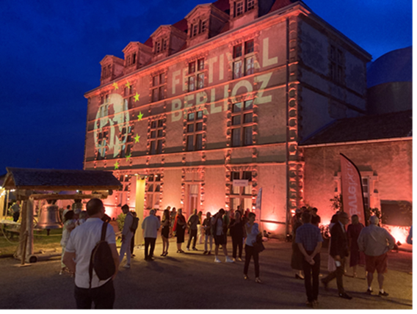

**ALASTAIR ABERDARE**